City of Marengo
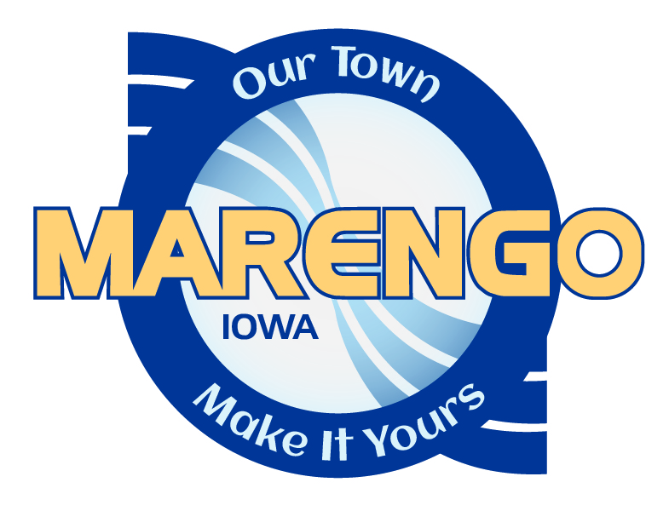
LOCAL “Downtown” BUSINESS SUPPORT PROGRAM
Overview of Downtown (C-1) District Grants: Commercial Exterior Grant and Sign Grant Programs

Program Objectives: Encourage business and property owners to enhance building appearance; creating a positive, inviting, and thriving downtown district image that visually encourages persons to spend time in Marengo.
Intended to Assist with the Following:
- Eliminate deterioration of buildings.
- Restore and Preserve Properties.
- Be a catalyst for larger improvements and development.
- Eliminate vacancies.

Eligible Project Area: The project area is described as the Downtown area, and is a subset of the city zoned C-1 Central Business District. Businesses operating out of a residence are excluded. Assessor classified commercial properties, located within the boundaries as defined below, are eligible:
- Court Avenue from Marion Street to May Street
- Main Street from Court Avenue to Marengo Avenue
- Marengo Avenue from Main Street to Hilton Street
- Washington Street from Court Avenue to Marengo Avenue
- Hilton Street from Court Avenue to Marengo Avenue

Program Overview:
Selection
- Grant program Executive Selection Committee to consist of (3) members: City Administrator, Appointed City Council Member, and MarenGO Community Development member.
- Program to be administered by the Marengo City Clerk.
- Applications to be reviewed by the Executive Selection Committee within 20 business days of receipt.
- Applications recommended for grant approval by Executive Selection Committee to be reviewed for consideration of city council approval on the fourth Wednesday of the month.
Funding
- Funding is allocated on a first-come, first-served basis. Program funding is based on fiscal year; July 1 – June 30.
- Upon depletion of grant funding, receipt of applications will be discontinued until the following fiscal year. Excess funds to be carried over.
- Labor costs only reimbursed for qualified third-party contractors, not business or property owners.
- Funds to be paid by city upon completion of project and submission of project receipt and proof of payment.
- Request for grant funds distribution must be made within 12 months of application submission.
Design Guidelines: It is the expectations of the selection committee that all submitted project store front designs, materials, color schemes, signage, windows, lighting and awning selections will follow the basic principles and best practices of the Downtown Design Guide administered by Iowa Economic Development.

Grant Types:

COMMERCIAL EXTERIOR GRANT

Who Qualifies: | Business Owner or Property Owner; property owner must submit letter of approval for business owner application.
What Qualifies: | Restoration/Rehabilitation of Facades/Exterior Walls; including design assistance, awnings, supplies, and contracted third-party labor.  Project alignment with the principles and best practices of the Iowa Economic Development Downtown design guide will be highly considered as part of the selection criteria. Copies of the design guide can be found here: https://www.iowaeda.com/UserDocs/downtowndesignguide.pdf
Grant Amount: | $10,000 Allocated per city’s fiscal year (July 1 – June 30) Across ALL Downtown District Grants.  Individual Commercial Exterior Grants cannot exceed one-third of the project costs.
How Often Can I Apply? | Once per fiscal year.
Ineligible Improvements: | - Real Estate or business acquisition costs.  - Interior remodeling, including the purchase of furnishing, equipment or other personal property that does not become part of the building.  - Landscaping and site improvements.  - Modification or removal of architectural and historical features.  - Roof improvements.  - Work commenced prior to the application approval (unless it was of an emergency nature).  - Working capital or inventory.  - Water/sewer service lines connection to city services.  - Labor costs only reimbursed for qualified third-party contractors, not business or property owners.

Grant Types continued:

SIGNS

Who Qualifies: | Business Owner. Property owner must submit letter of approval for business owner application.
What Qualifies: | Installation of Business Signage that is attached to Building, and any Associated Lighting.
Grant Amount: | $10,000 Allocated per city’s fiscal year (July 1 – June 30) Across ALL Downtown District Grants.  Individual Signs grants cannot exceed $2,500.
How Often Can I Apply? | Once per Business.
Ineligible Improvements: | Stand-alone signs (signs not attached to building).

Questions regarding the above Business Incentive Grants can be directed to City of Marengo City Hall at 319-642-3232 or email at cityofmarengo@marengoiowa.com.

